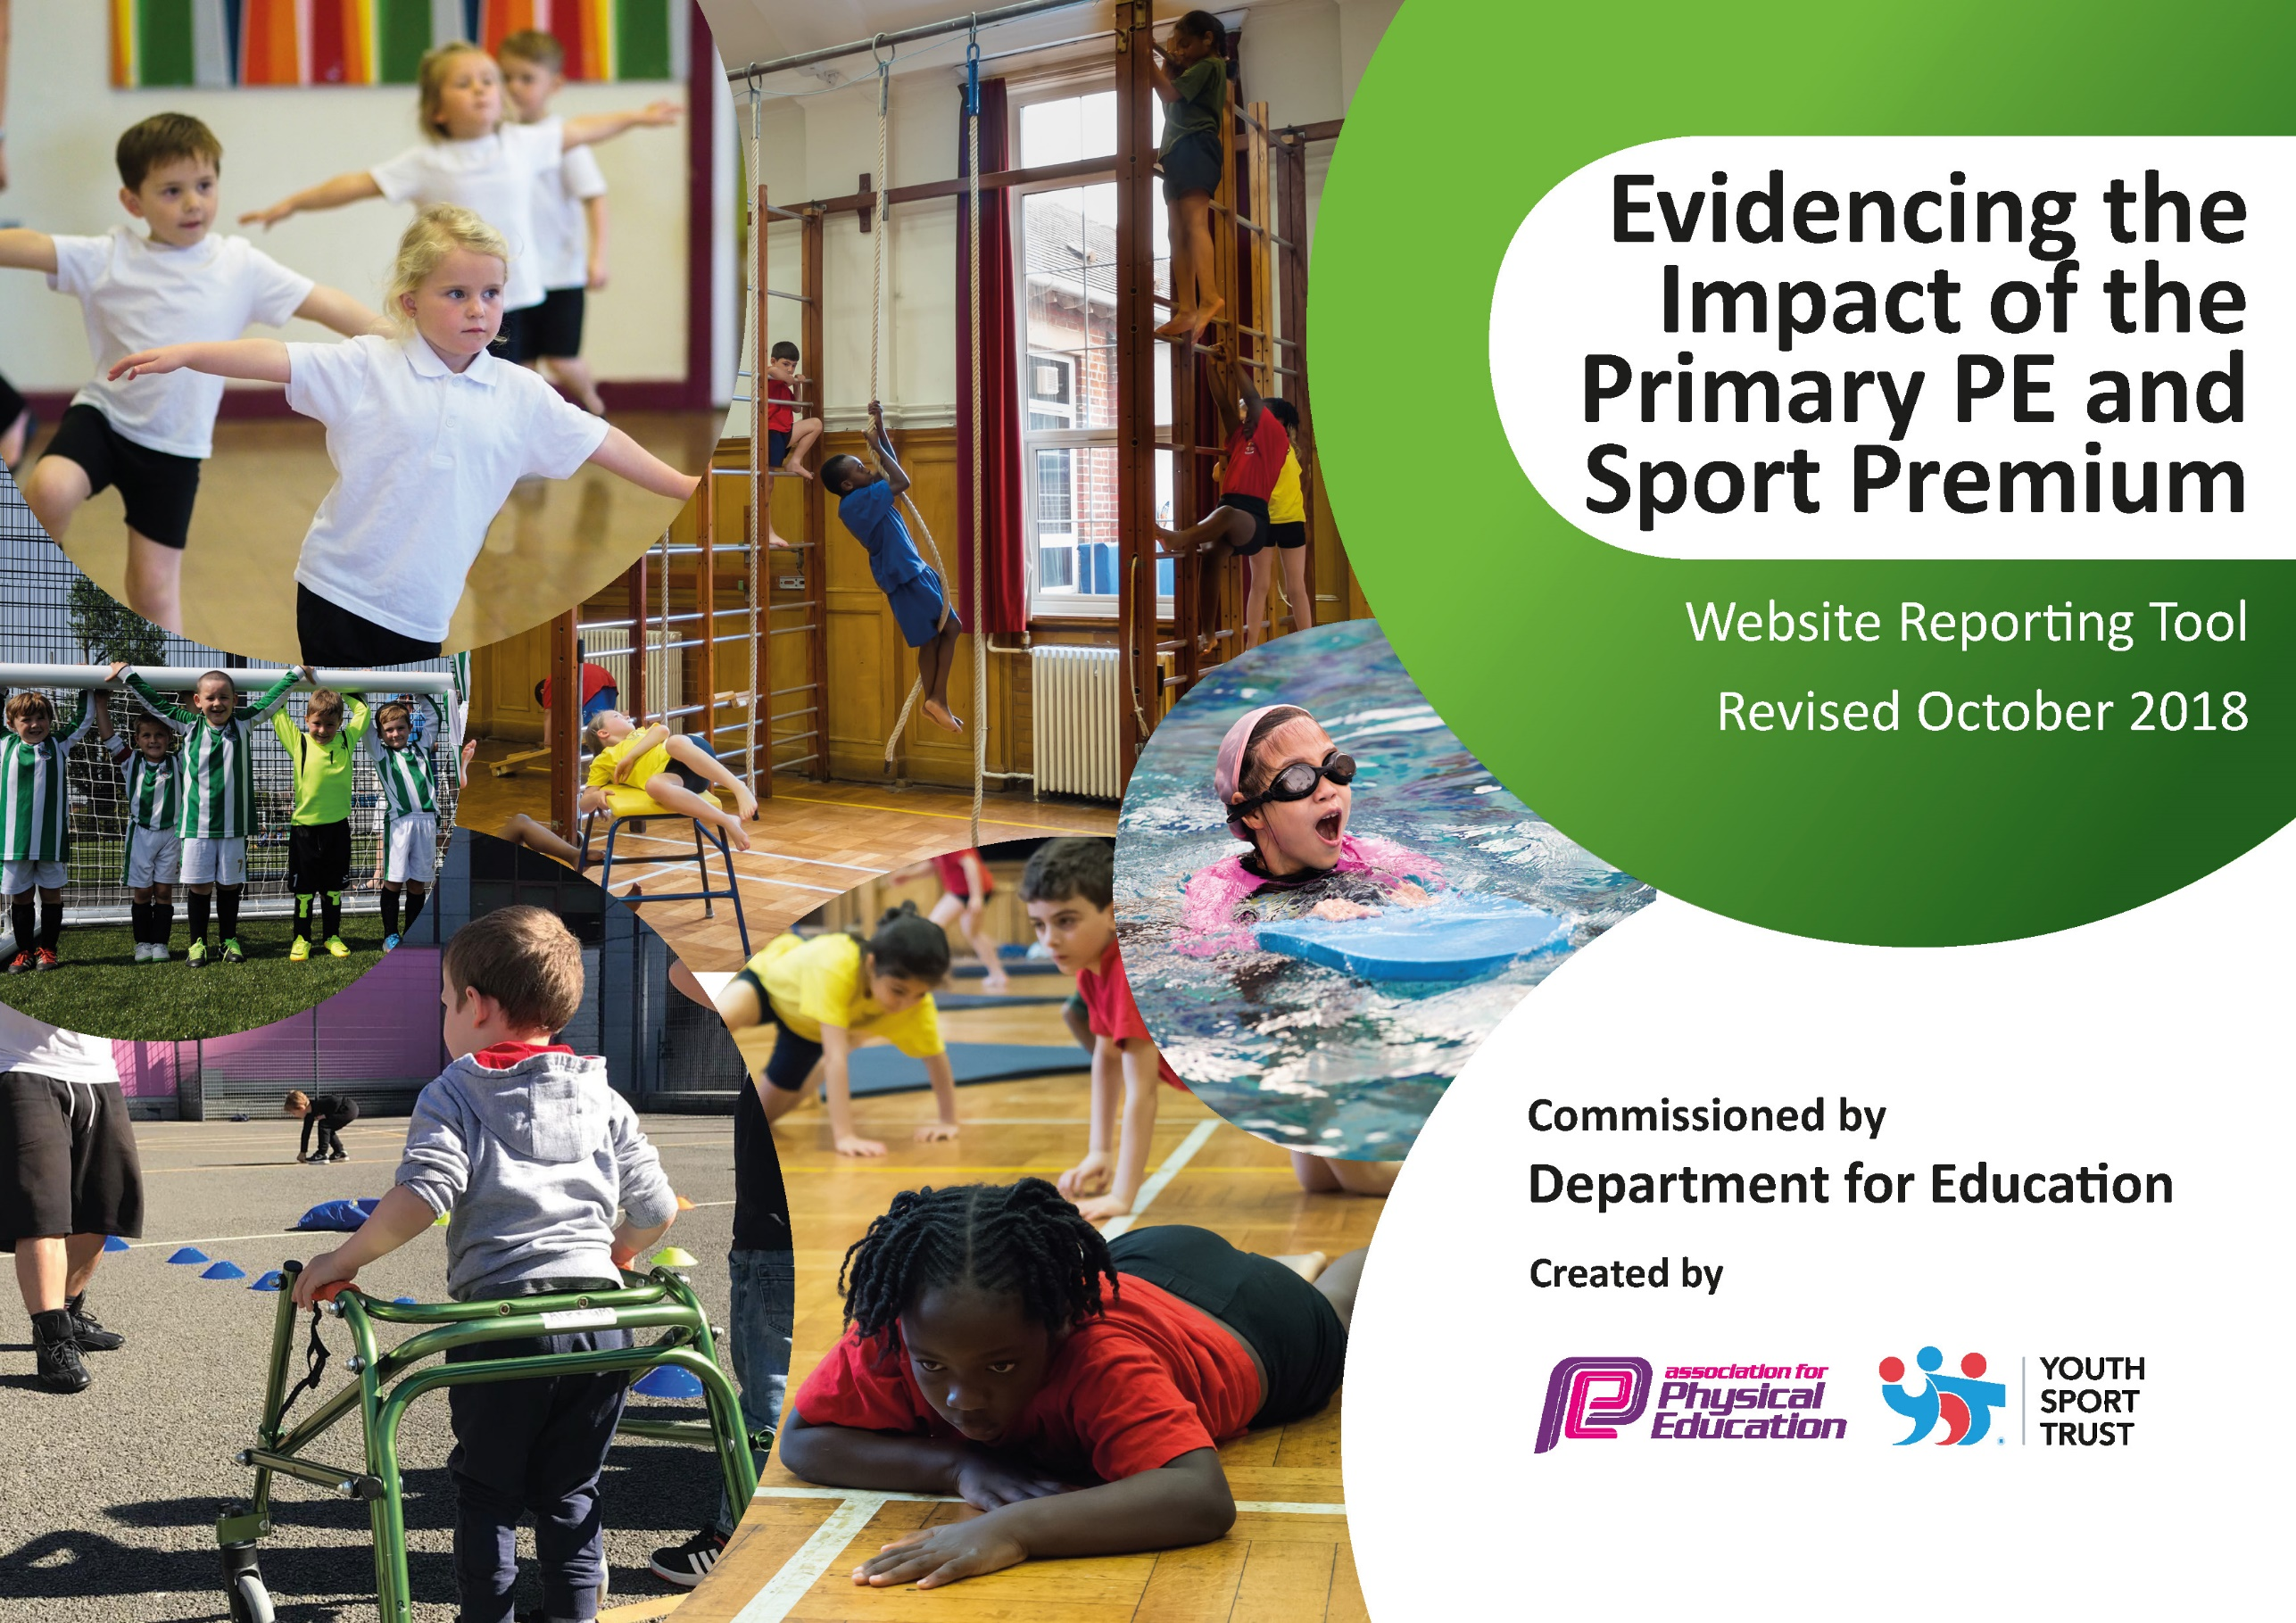
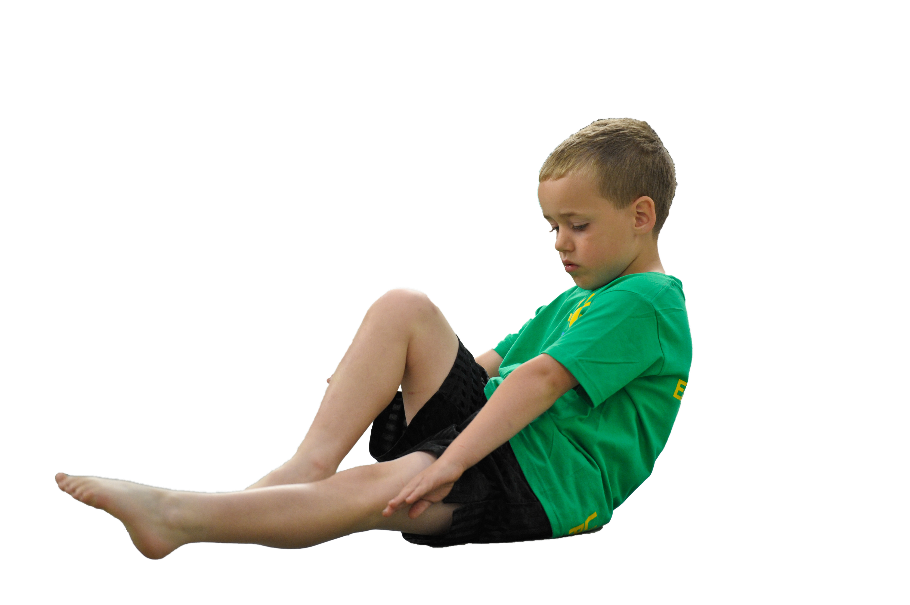
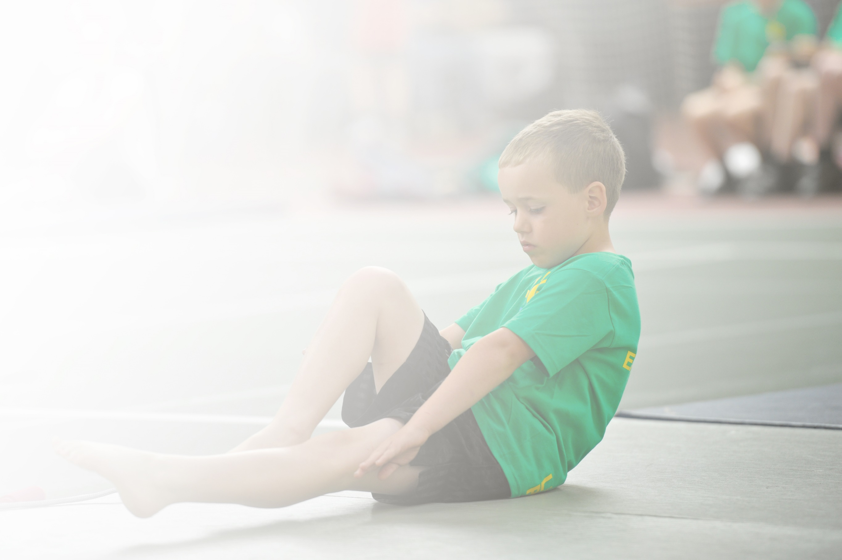
Schools must use the funding to make additional and sustainable improvements to the quality of Physical Education, Sport and Physical Activity (PESPA) they offer. This means that you should use the Primary PE and Sport Premium to:

- Develop or add to the PESPA activities that your school already offer
- Build capacity and capability within the school to ensure that improvements made now will benefit pupils joining the school in future years

Please visit gov.uk for the revised DfE guidance including the 5 key indicators across which schools should demonstrate an improvement. This document will help you to review your provision and to report
your spend. DfE encourages schools to use this template as an effective way of meeting the reporting requirements of the Primary PE and Sport Premium.

We recommend you start by reflecting on the impact of current provision and reviewing the previous
spend. Under the Ofsted Schools Inspection Framework, inspectors will assess how effectively leaders use the Primary PE and Sport Premium and measure its impact on outcomes for pupils, and how effectively governors hold them to account for this.

Schools are required to publish details of how they spend this funding as well as on the impact it has on pupils’ PE and sport participation and attainment by the end of the summer term or by 31 July 2019 at the
latest.
We recommend regularly updating the table and publishing it
on your website throughout the year, as evidence of your
ongoing review into how you are using the money to
secure maximum, sustainable impact. To see an
example of how to complete the table please
click HERE.

Support for review and reflection - considering the 5 key indicators from DfE, what development needs are a priority for your setting and your students now and why? Use the space below to reflect on previous spend, identify current need and priorities for the future.

Key achievements to date: | Areas for further improvement and baseline evidence of need:
We have run the PECS programme for 4 years and staff are now more confident in the delivery of PE.  Pupil fitness has improved as evidenced in our Healthy Active Schools database.  Increased participation in competitive sports. Last year we had 4 inter school competitions. Intra school competition has also.  New curriculum to support staff and ease teacher workload in planning, also to ensure a development in skills is provided in less familiar areas such as gym and dance. Staff training in gym and dance through Aspire PECS programme and Dancedesk.  Yoga programme for YR pupils has highlighted new ways of being active to the whole school, this is now being replicated in Nursery. | Pupils to continue Yoga into year 1. Year 2 to also access the programme.  Year 6 to have yoga as a pre SATs workshop.  Increase pupil activity levels in school time through active maths- Maths of the Day and SuperMovers.  5 Year 6 pupils will not have met swimming requirements- therefore funds are being allocated to provide additional swimming tuition for those pupils this year.  More school games competition  Staff development work as new staff in Year 3 and Reception

Meeting national curriculum requirements for swimming and water safety | Please complete all of the below:
What percentage of your current Year 6 cohort swim competently, confidently and proficiently over a distance of at least 25 metres?  N.B. Even though your children may swim in another year please report on their attainment on leaving  primary school. | 67%
What percentage of your current Year 6 cohort use a range of strokes effectively [for example, front crawl, backstroke and breaststroke]? | 67%
What percentage of your current Year 6 cohort perform safe self-rescue in different water-based situations? | 67%
Schools can choose to use the Primary PE and Sport Premium to provide additional provision for swimming but this must be for activity over and above the national curriculum requirements. Have you used it in this way? | Yes/No

Action Plan and Budget Tracking
Capture your intended annual spend against the 5 key indicators. Clarify the success criteria and evidence of impact that you intend to measure to evaluate for students today and for the future.

Academic Year: 2018/19 | Total fund allocated: £ 17,060 | Date Updated: 25/03/19
Key indicator 1: The engagement of all pupils in regular physical activity – Chief Medical Officer guidelines recommend that primary school children undertake at least 30 minutes of physical activity a day in school |  |  |  | Percentage of total allocation:
 |  |  |  | 31.4%
School focus with clarity on intended impact on pupils: | Actions to achieve: | Funding allocated: | Evidence and impact: | Sustainability and suggested next steps:
Pupils have access to high quality lunchtime physical activity in order to help them meet the daily target of 30 minutes.  Swimming Intervention for the 10 pupils now in Y6 yet to meet NC requirements despite school swimming provision.  Ensure school has suitable equipement for high quality PE to be taught | Train 14 year 5 pupils as Play Activators in order to support and encourage play (Aspire Sports).  All year 5 pupils undergo Sports Leader training with the Albion Foundation.  Aspire Sports coach leads lunchtime focused activity one lunchtime per week.  Swimming lessons x1 per week for 8 week period  Upkeep and purchase of new PE and gymnastics equipment | £360  £1500  £1108.15  £400  £2000 | 14 Pupils trained as play activators October 2018. Operating as play leaders on KS1 and KS2 playgrounds, providing opportunity for 40 minutes physical activity per day for all pupils.  15 children each Wednesday lunchtime have focused active play with the sports coach.  £678 spent on upkeep and replacement of new gymnastics equipment. £1000 Spent on Action Mats  £73.25 on an electric ball pump to ensure that equipment is always ready to use. | Pupils will be able to support next year’s Y5 pupils in this role.
Key indicator 2: The profile of PESSPA being raised across the school as a tool for whole school improvement |  |  |  | Percentage of total allocation:
 |  |  |  | 24.9%
School focus with clarity on intended impact on pupils: | Actions to achieve: | Funding allocated: | Evidence and impact: | Sustainability and suggested next steps:
Staff become increasingly aware of how increased physical activity can improve social and emotional well being of pupils as well as curricular attainment in non sports subjects.  Reception and Year 1 children to increase in focus and concentration- showing improved listening skills. | Maths of the Day Resource renewed  Super Movers resources shared with staff  Yoga Programme for Reception and year 1 and 2.  Year 6 to have a six week pre SATs Yoga and mindfulness  10 Year six pupils engage in Maths on the Move (Aspire Sports) | £500  Free  £3750  £300 | Maths of the day resource used throughout the year but feedback from teachers and pupils informed that this was not beneficial to maths and therefore not a good use of spend. Will not resubscribe.  Supermovers used across school to increase activity levels, on average pupils across school getting an hour more active time per week as a result.  Yoga programme very successful and developing control, confidence and listening skills in reception. Pupils all made minimum 25% increase in all areas as per report.  100% Pupils in MOTM programme reached expected levels in maths in Y6 SATs.  0 incidents of Y6 pupils not mentally resilient for SATs. | Yoga programme will continue for Reception children into year 1 and year 2.

Key indicator 3: Increased confidence, knowledge and skills of all staff in teaching PE and sport |  |  |  | Percentage of total allocation:
 |  |  |  | 23.5%
School focus with clarity on intended  impact on pupils: | Actions to achieve: | Funding  allocated: | Evidence and impact: | Sustainability and suggested  next steps:
Subject leader supported in developing the subject across school – providing high quality PE which raises standards and outcome sin pupils.  Pupils to show increased ability and fitness- highlighted in termly fitness assessments. | Membership of Dancedesk Hub- provides membership of AfPE and Youth Sport Trust (Level 1)  PECS Programme with teachers (Aspire Sports)  Scheme to support Early Years  Develop teacher confidence in Dance and outdoor education. | £600  £2216.30  £200  £350 | Leader has attended training on Active learning cards and the way that these can be used to raise activity levels in other curriculum areas.  Year 3 teacher and Nursery teacher completed PECS programme in the Autumn term. Year 2 Teacher in the Spring term. Year R teacher in the summer term.  Leader attends PESS Conference 29/03/19  Actions Kids Scheme purchased for Nursery (49.99) and Reception (129.99)  CAAPS books for KS2 ordered to develop Outdoor learning.  Year 2 teacher to attend Level 3 Dance teacher training. 23/5/19 and 05/06/19 | School has resources to keep and information to be disseminated to all staff.
Key indicator 4: Broader experience of a range of sports and activities offered to all pupils |  |  |  | Percentage of total allocation:
 |  |  |  | 10%
School focus with clarity on intended  impact on pupils: | Actions to achieve: | Funding  allocated: | Evidence and impact: | Sustainability and suggested  next steps:
Children experience a wider range of physical activity. Largely aimed at developing good habits in early years but also broaden the horizons of pupils across school. | Yoga Bugs to carry out Impact and Change Programme with Reception children, also for this year Year 1 and 2.  Aspire Sports to deliver Balanceability bike training with Reception class- Spr 1  After School Club 1x per week to introduce new sports to children | £3750* (already accounted in KI 2)  £675  £1108.15 | After School Club: Autumn 2- Ultimate Frisbee; Spring 1- Multi Skills; Spring 2- Basketball  Balanceability delivered to Reception pupils Spring 1 2019.  Yoga delivered to Year 1.
Key indicator 5: Increased participation in competitive sport |  |  |  | Percentage of total allocation:
 |  |  |  | 11.7 %
School focus with clarity on intended  impact on pupils: | Actions to achieve: | Funding  allocated: | Evidence and impact: | Sustainability and suggested  next steps:
To increase participation in competitive through the School games programme. School to aim for the School Silver games mark | Funding set aside to fund transportation to competitions | £1500 | Swimming Competition 12/01/19  £180 for coach. Children placed first in boys competition and third in girls.  Basketball Competition 28/03/19 (£180 for coach) Boys finished 2nd

